

**Mathematics Specialist**

**Test 4 2017**

**Integration Techniques &**

**Applications of Integral Calculus**

**NAME: _______________________________________________ TEACHER: Mrs Da Cruz**

**Resource Free Section**

**33 marks**

**35 minutes**

**Question 1 [3 & 3 = 6 marks]**

1. Express  as partial fractions.
2. Hence determine Give your answer in the form .

**Question 2 [3, 2 & 2 = 7 marks]**

Determine the following indefinite integrals:

(a)

-

(b)

(c)

**Question 3 [5 marks]**

Use the substitution to evaluate .

Do not factorize or simplify your answer.

**Question 4 [1 mark]**

The area under the curve *y* = *k*(*x*) can be described by:

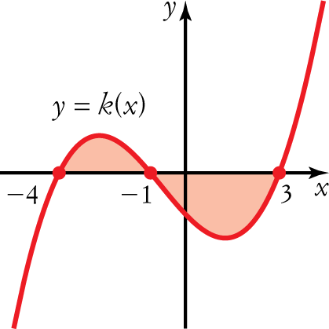

A 

B 

C 

D 

E 

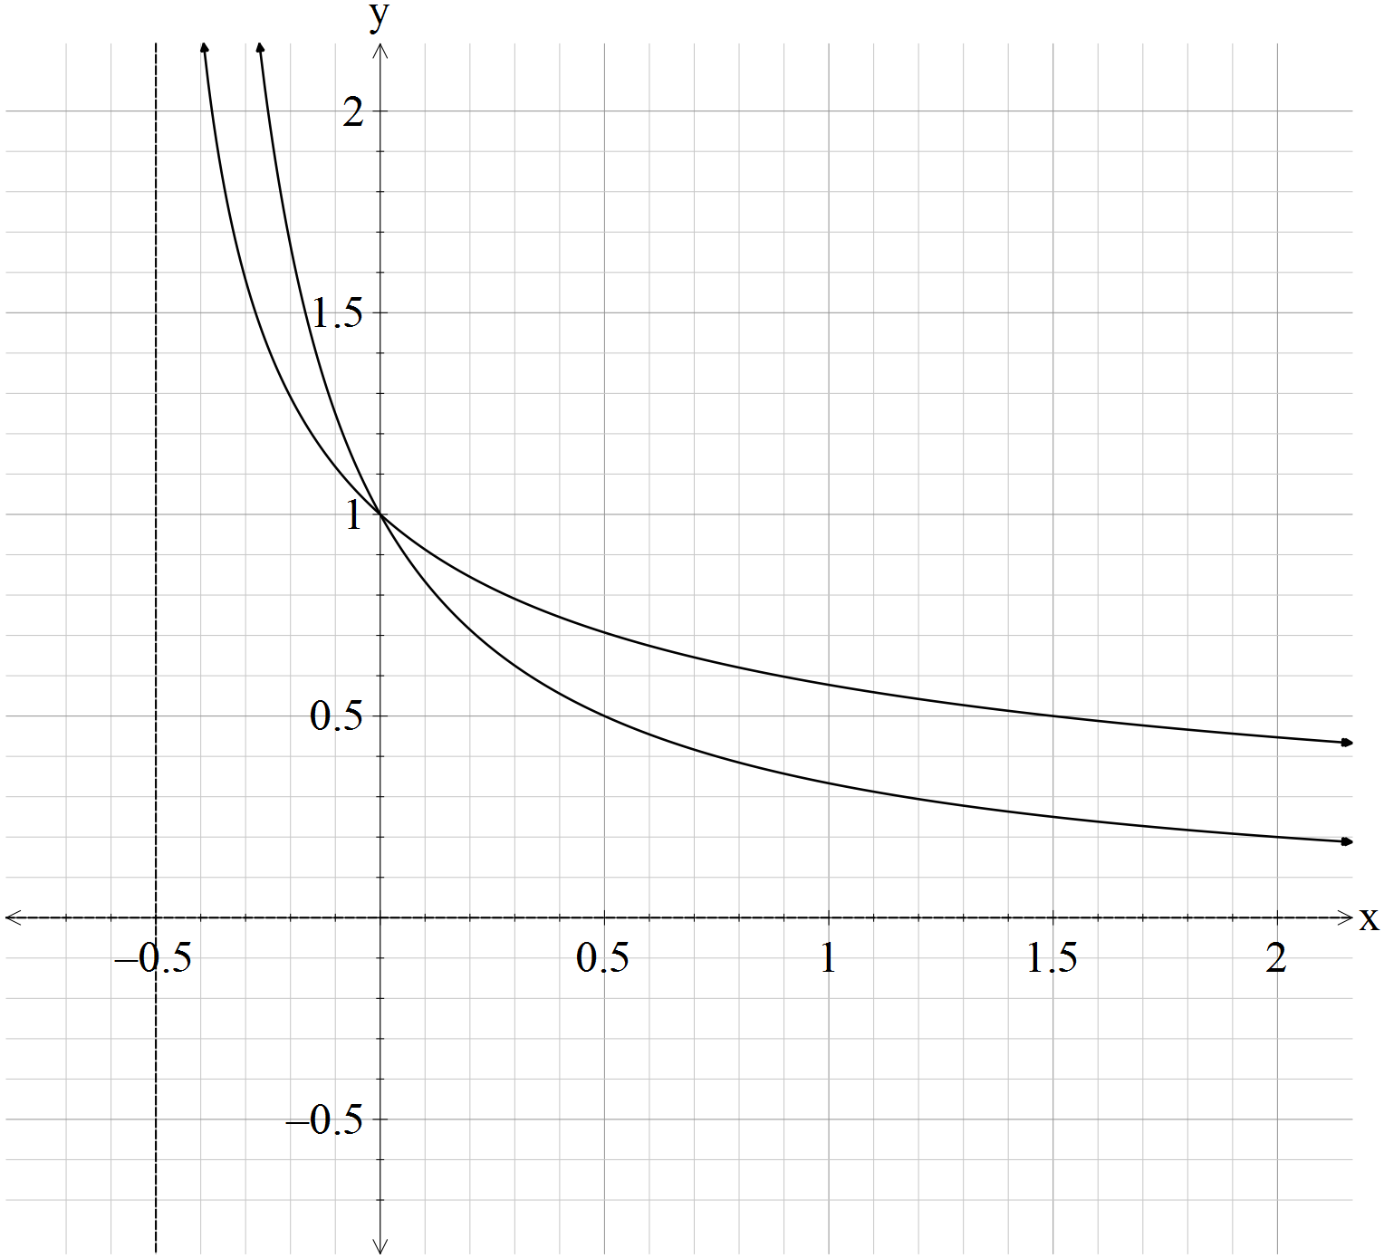**Question 5 [3 & 4 = 7 marks]**

1. Find the area under the curve, in square units, for the function from to
2. Find the area enclosed by the curves, in square units, of the graphs ,

and the line

**Question 6 [2 marks]**

Find and use your answer to evaluate

**Question 7 [5 marks]**

The region bounded by the lines and and the curve is rotated about the

x-axis 180. The volume formed is . Determine the value of where is a positive integer.

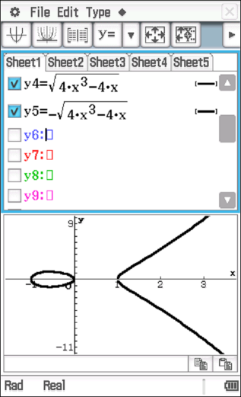



**Mathematics Specialist**

**Test 4 2017**

**Integration Techniques &**

**Applications of Integral Calculus**

**NAME: _______________________________________________ TEACHER: Mrs Da Cruz**

**Resource Rich Section**

**11 marks**

**15 minutes**

**One unfolded A4 page of notes, SCSA formulae booklet and ClassPad calculator permitted**

**Question 8 [1, 1 & 2 = 4 marks]**

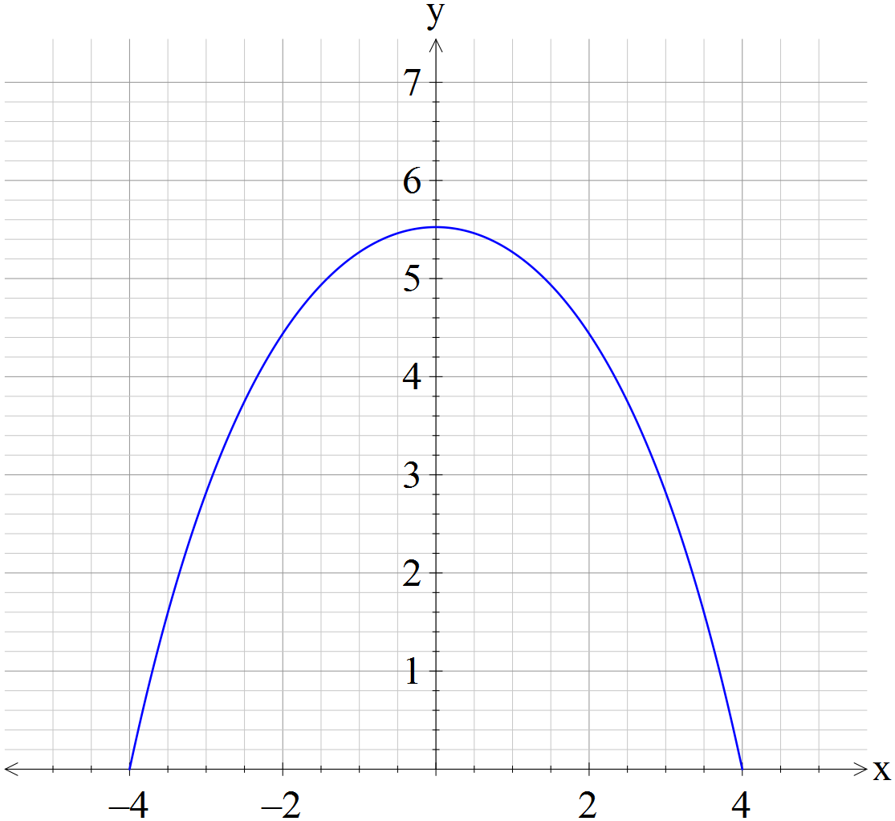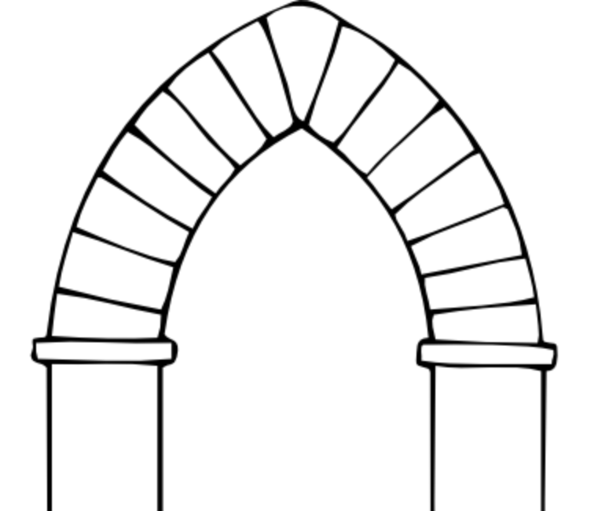

The upper component of an archway is designed to bear the load of the wall above and around it. For this, the best shape is a catenary. A catenary is the name given to the curve formed by two simple exponential terms added together. The equation of the upper arch is .

The *x*-intercepts of the catenary are (−4, 0) and (4, 0).

**a** Use this information to determine the exact value of *c*.

Paint has to be applied to the area under the catenary curve.

**b** State a definite integral that will find the area of paint required.

**c** Calculate the exact area to be painted, giving your answer with positive indices.

**Question 9 [2 marks]**

Use a suitable definite integral to find the **exact** volume, in cubic units, that is formed by rotating about the *x*-axis the following curves between the limits shown.

*y* = , from *x* = 1 and *x* = 3.

**Question 10 [3 marks]**

Use a suitable definite integral to find the exact volume, in cubic units, that is formed by rotating about the *y*-axis the following curves between the limits shown.

****, from *y* = 0 and *y* = 1.

**Question 10 [2 marks]**

Use a suitable definite integral to find the exact volume, in cubic units, that is formed by rotating the shaded area about the *y*-axis.

